**Chapter 3: Consciousness and the Two-Track mind**

**Defining consciousness**

At the beginning, psychology was defined as “the description and explanation of states of consciousness”, but then psychologists find it difficult to study consciousness scientifically and they evolve psychology to the direct observation of behavior.

1. **Consciousness**

**Consciousness**: our subjective awareness of ourselves (thoughts, memories, feelings, sensations) and our environment

**Functions** of consciousness

* Adaptability & flexibility: conscious awareness allows to **assemble information from many sources: reflection on the past, adaption to present, planning for future**
* Attention & Learning: conscious awareness allows to **focus attention when learning complex concepts or behaviors**

States and levels of consciousness

* **Altered states** of consciousness ( dreams, hallucinations, meditation…)
* **‘normal walking’** awareness
* **Reflexive consciousness**: being conscious of being conscious

Benefit of consciousness

* Reproductive advantage
* Cope with novel situations and act in our long-term interests
* Promote our survival by anticipating how we seem to others and helping us read others’ minds

**Cognitive neuroscience**: the interdisciplinary study of **the brain activity linked with cognition** (including perception, thinking, memory and language)

* Linking brain states and conscious experiences (Correlation)

Eg: when you ask an unconscious patient to play tennis, his brain area which controls the arm and leg movements shows signals in fMRI scans, and this partly overlap with a healthy patient’ brain activity.

Based on your cortical action patterns, scientists can now, in limited ways, read your mind. They can tell which of 10 similar objects you were viewing.

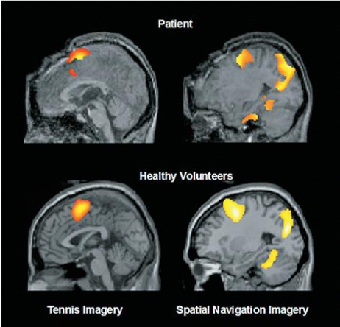

* Conscious experience arises from **synchronized activity** across the brain
* **Shift in your attention result in string of consciousness; and consciousness involves attention** (perception, dreaming, solving problems…)
* **Attention has a limited capacity**
* **Attention is selective** (selective filters of sensations) Your conscious mind is in one place at a time

**Selective attention**: the focusing of conscious awareness on a particular stimulus

* Most of the time we are unaware of the process of our selection
* We don’t always “choose” to attend stimuli: some stimuli (pain) just grab attention externally

**The cocktail party effect**: your ability to attend to one voice among a sea of other voices

**Controlled filters of selective attention**: ability to focus one’s auditory attention on a particular stimulus (one conversation) while filtering out a range of other stimuli (other conversations, background noises)

**Automatic filters of selective attention**: some stimuli will attract attention if they carry importance information

Influence of cognitive bias:

If a guy is exclusively given boy toys, then he is prone to pay more attention to boy toys later on.

* **Consciousness has different states**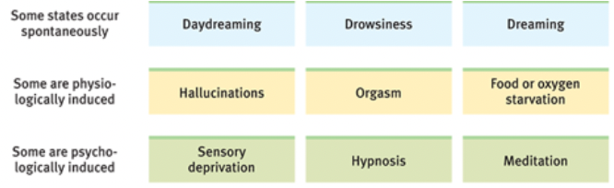

Normal states of consciousness = average level

* **Information outside our awareness is also constantly processed**

(dual processing and the two-track mind)

28 percent of drivers admit to texting or talking on their phone while driving.

**Inattentional blindness**: **Failing to see** very visible objects when our attention **is directed elsewhere**

Eg: when you focus on counting the white-shirt guys passing the boy, you don’t notice there was a gorilla passing by.

If you focus on phones while across the road, you fail to notice the cars speeding towards you.

**Inattentional deafness**: **Failing to hear** very visible objects when our attention is directed elsewhere.

**Change blindness**: **failing to notice changes** in the environment when our attention is directed **elsewhere**; a form of inattentional blindness

**Change deafness**: failing to notice changes in **auditory** stimulus by the listener.

**Choice blindness**: people’s blindness **extends to their own choices**

Eg: people focus on choosing the most attractive girl don’t notice that some girls are changed

Limits to attention:

We think we see more than we see, and we don’t know what we don’t see. It’s easy to miss things you are not looking for.

**Popout**: occurs if there is a **single target that differs** **from its surrounding** while all distractors (or the rest of the scene) are **homogeneous**

**Shared attention**: focus on two things at the same time

**The dual-task paradigm**

Procedure in experimental psychology that requires an individual to perform two tasks simultaneously, in order to compare performance with single-task conditions

* Decrease in efficiency
* By how much efficiency decreases depends on the complexity of each task

**Dual processing**: the principle that information is often simultaneously processed on separate **conscious and unconscious tracks**.

* Unconscious information processing occurs **simultaneously** to conscious information processing on many **parallel tracks**
* Perception, memory, thinking, language and attitudes all operate on **two levels**: a conscious, deliberate, reflective ‘high road’ and an unconscious, automatic, intuitive ‘low road’;

Eg: experienced driver knows how to move to the right lane, but he cannot accurately explain it, because our brain converts conscious into unconscious knowledge.

**Blindsight**: a condition in which a person **can respond to a visual stimulus without consciously experiencing it**

Eg: a woman who can’t discriminate objects visually can slip a postcard into a horizontal mail slot without any error.

Brain waves seem indicate that **we consciously experience the decision to move** after **the decision has already fired in the brain**

* Action sometimes precedes awareness

Eg: a skilled tennis player’s brain and body respond automatically to an oncoming serve before becoming consciously aware of the ball’s trajectory

**Vision is a dual-processing system**:

Vision perception track enables us to “think about the world”- to recognize things and to plan future actions.

Visual action track guides our moment-to moment movements.

Unconscious information processing:

Normally sighted people whose visual cortex is disabled with magnetic stimulation can nevertheless sense the emotion expressed in faces

**Parallel processing**: processing many aspects of a problem simultaneously; generally used to process **well-learned information or to solve easy problems**

* Enable to take care of routine business

**Sequential processing**: processing one aspect of a problem at a time; generally used to process new information or to solve **difficult problems**

* Enable to solve new problems

Eg: a skilled tennis play’s brain and body respond automatically to an oncoming serve before becoming aware of the ball’s trajectory.

Some processes become **automatic** as they develop

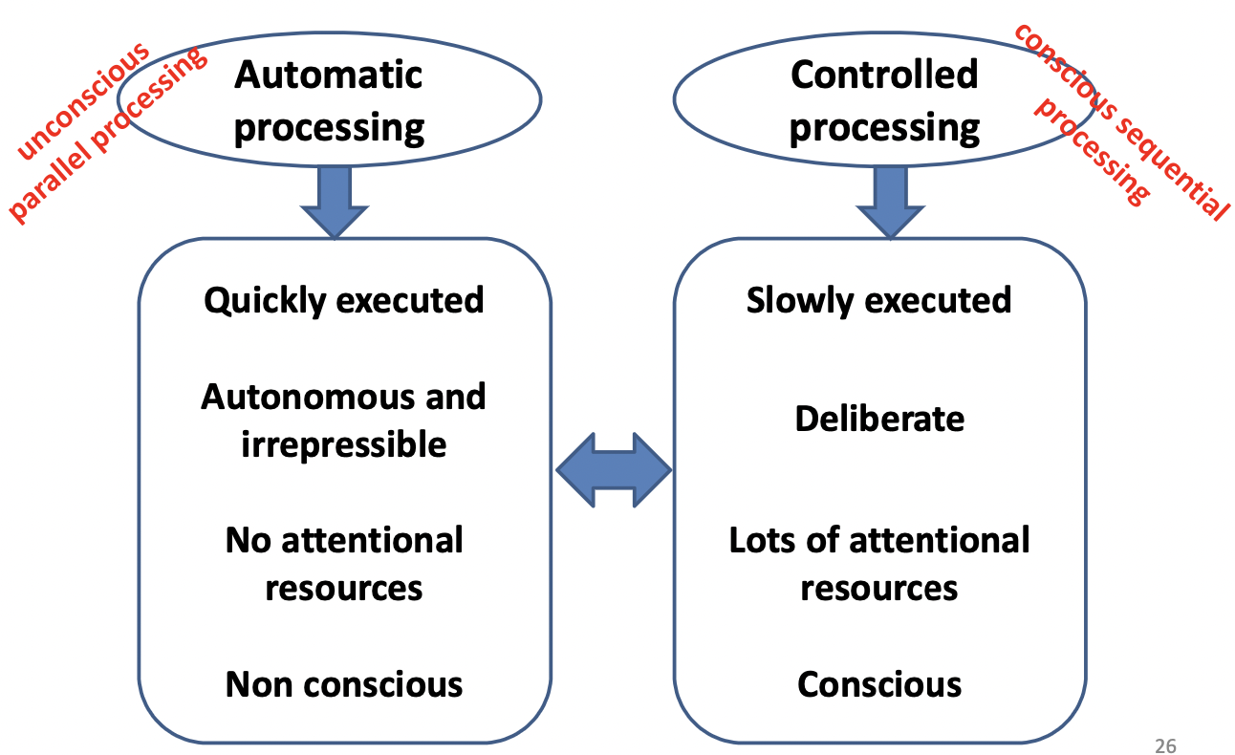

Collective consciousness: Genes, habits, cultures, law, ideas are inherited. Everyone and everything are connected.

Infants help spontaneously, without expecting a reward

Happiness correlates with **giving** to others

We survived and thrived because we take care of each others

1. **Sleep**

**Sleep**: a periodic, natural loss of consciousness

≠**unconsciousness**<coma, general anesthesia, hibernation

When you’re asleep, you are not unconscious

The brain is still 100% active when we sleep

* The brain’s **auditory cortex responds to sound stimuli** even during sleep

**Circadian Rhythm**: our “biological clock”

Regular body rhythms (eg: for temperature and wakefulness) that occur on a 24h cycle

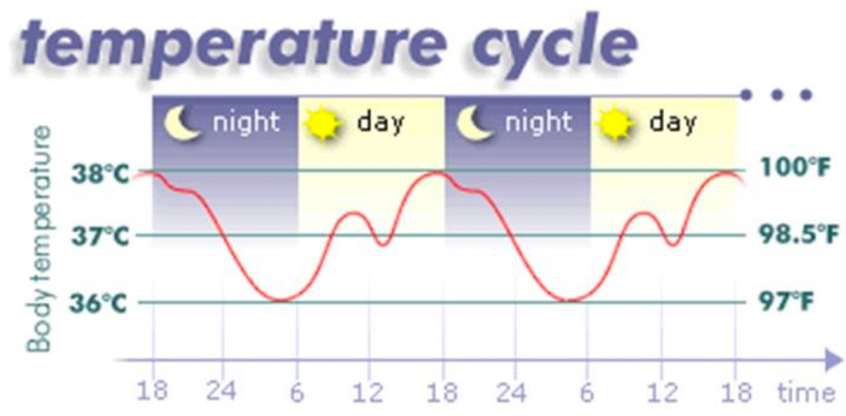

Age and experience can alter our circadian rhythm.

* Most 20-year-olds are evening-energized “owls” while older adults are morning-loving “larks”.
* In general, night owls tend to be smart and creative. Morning types tend to do better in school, take more initiative, be more punctual, and be less vulnerable to depression.

**Measuring Sleep**:

EEG (brain waves) and EMG (muscle tension)

**Alpha waves**: the relatively slow waves of a **related, aware** state

**Beta waves**: an **alert, waking** state

**Delta waves**: the **large, slow brain waves** associated with **deep sleep**

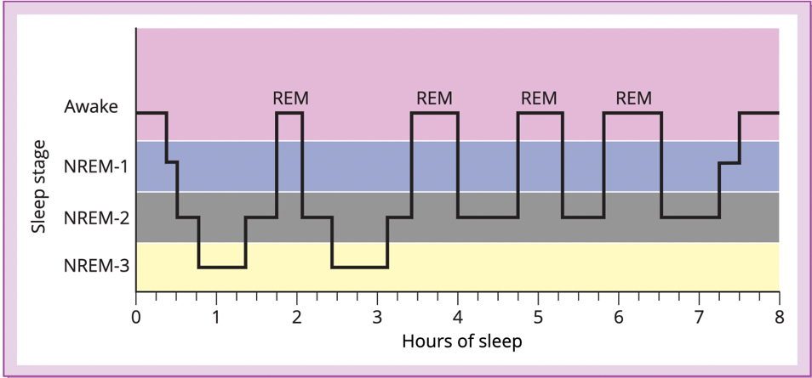

**Sleep cycle:**

The full sequence (dipping into deeper sleep, moving to lighter sleep and then REM sleep). It is repeated 3 to 5times in a typical night. Notice that most of the deep sleep (NREM 3) occurs in the first half of sleep, while more REMS occur in the last few hours.

**Sleep stages**: biological rhythm of our sleeping; around every 90minutes, we cycle through distinct sleep stages

**REM sleep**: Rapid Eye Movement sleep: a recurring sleep stage during which dreams commonly occur

**NREM sleep**: non-REM sleep

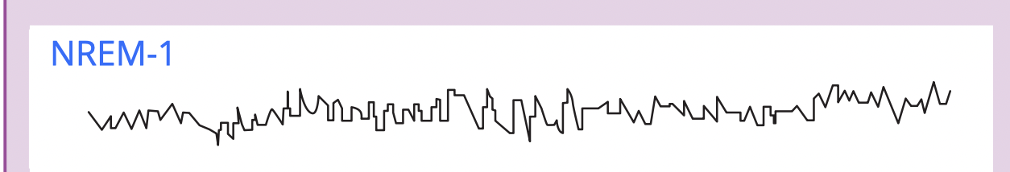

**NREM-1**: stage of light sleep without rapid eye movements, characterized as relatively small and irregular EEG waves

During NREM-q, you may experience fantastic images resembling hallucinations—sensory experiences that occur without a sensory stimulus.

You may have a sensation of falling (at which moment your body may suddenly jerk) or of floating weightlessly. These ***hypnagogic* sensations** may later be incorporated into your memories. People who claim they were abducted by aliens—often shortly after getting into bed—commonly recall being floated off of or pinned down on their beds

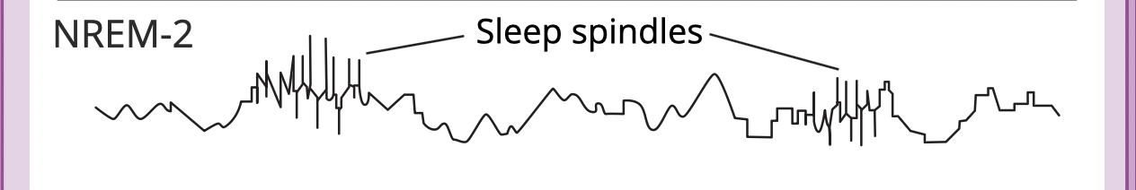

**NREM-2** (20 mns): stage between light sleep and deep sleep, characterized by EEG waves without rapid eyes movements, and occasional high activity called ***sleep spindles***. (bursts of rapid, rhythmic brain-wave activity)

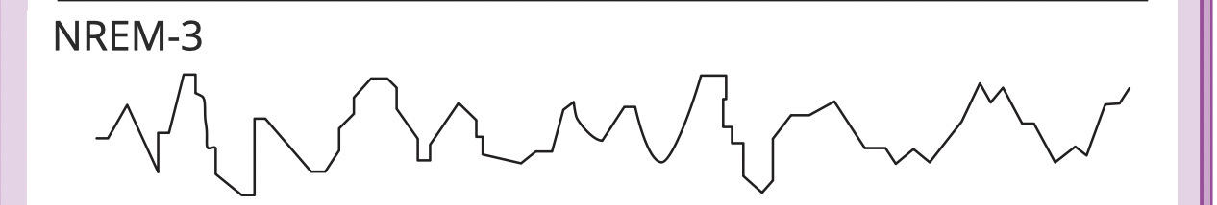

**NREM-3** (30mns): stages of deep sleep without rapid eye movements, characterized by large, slow EEG waves

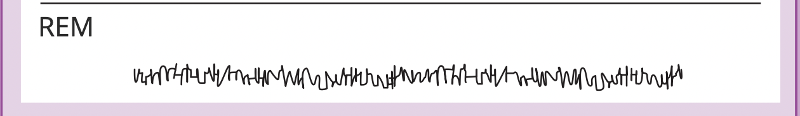

**REM**: stage of sleep characterized by rapid eye movements and small, irregular EEG waves; most dreams occur during this stage (heart rate rises, breathing becomes rapid and irregular)

We normally experience NREM-2 again before entering REM sleep. During REM sleep, the brain is highly active, but the whole body (except the eyes) is almost completely paralyzed.

**What affects our sleep patterns?**

* In average, people need 8h of sleep
* **Sleep patterns vary amongst individuals**
* Sleep patterns are **genetically** influenced (sleep-regulating genes)
* Sleep patterns are also **culturally** influenced

(social media leads to later bedtime, US adolescents get less sleep than Australians)

Whether for work or play, **bright light** tweaks the circadian clock by activating light-sensitive retinal proteins. These proteins control the circadian clock by triggering signals to the brain’s **suprachiasmatic nucleus (SCN)**—a pair of grain-of-rice-sized, 10,000-cell clusters in the hypothalamus that controls circadian rhythm. The SCN does its job partly by causing the brain’s ***pineal gland*** to decrease its production of the sleep-inducing hormone ***melatonin***in the morning and to increase it in the evening, thus modifying our feelings of sleepiness.

**Benefits of sleep**

1. **Sleep protects**

A species’ sleep pattern tends to suit its ecological niche: animals with the greatest need to graze and the least ability to hide tend to sleep less. Animal also sleep less, with no ill effects, during times of mating and migration.

1. **Sleep helps us recuperate**

Sleep helps **restore the immune system** **and repair brain tissue**: it gives resting neurons time to repair themselves, while pruning or weakening unused connections

1. **Sleep helps restore and rebuild our fading memories of the day’s experiences**

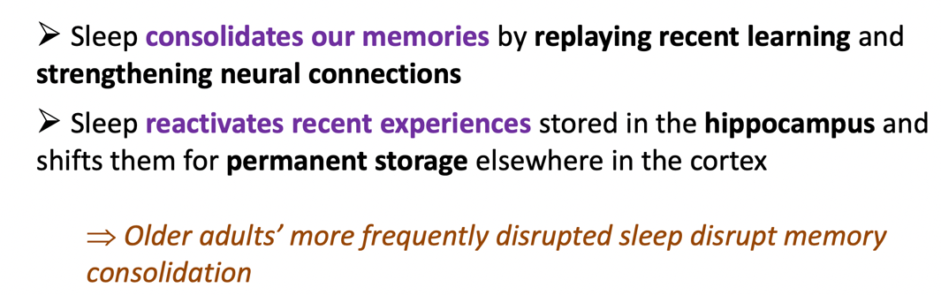

1. **Sleep feeds creative thinking**

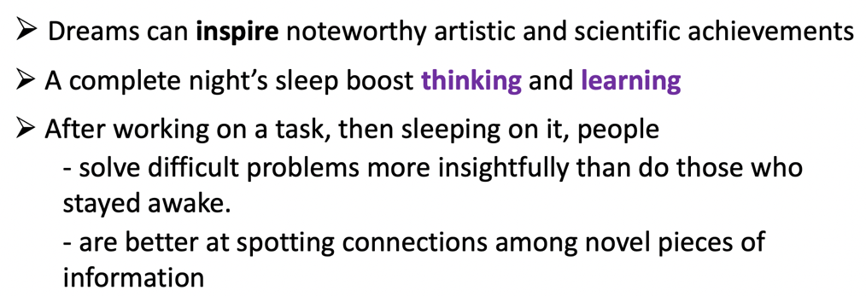

1. **Sleep supports growth**

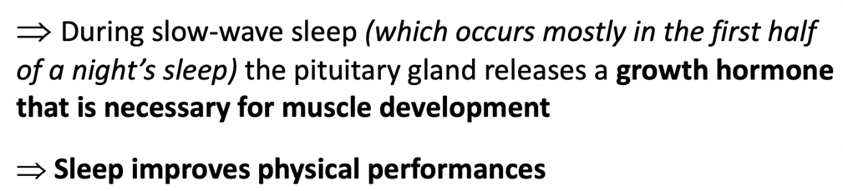

**Sleep Deprivation and Sleep Disorders**

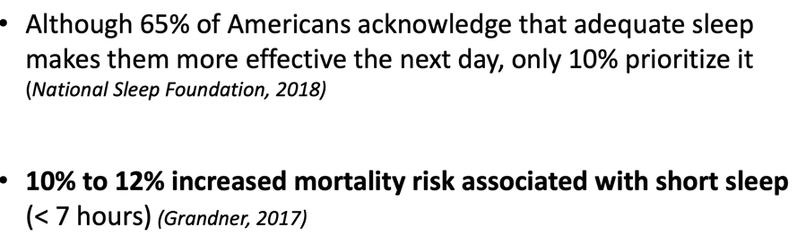

1. Sleep loss is a predictor of depression

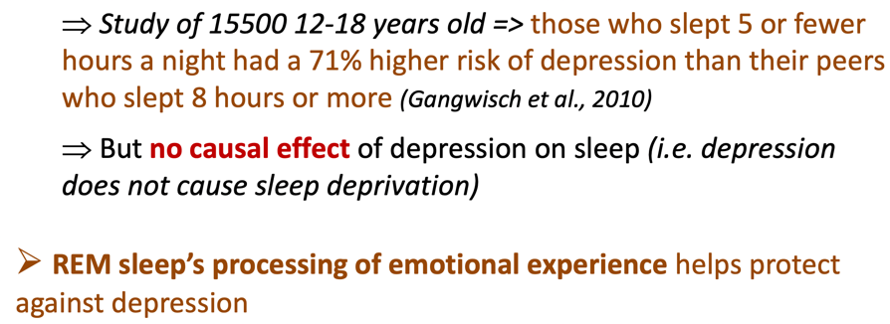

1. Lack of sleep can cause weight gain

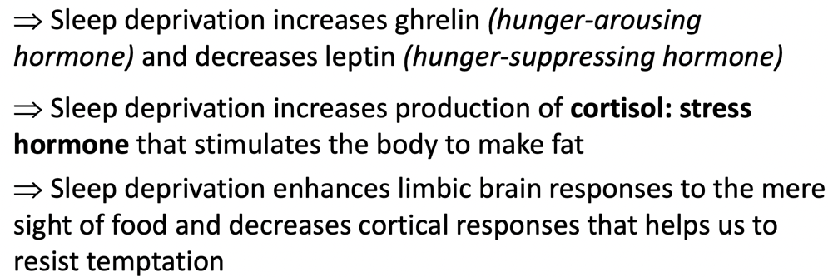

1. Lack of sleep affects physical health

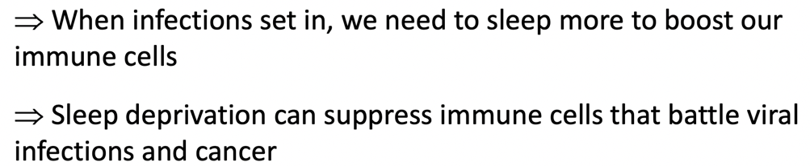

Less sleep = More accidents

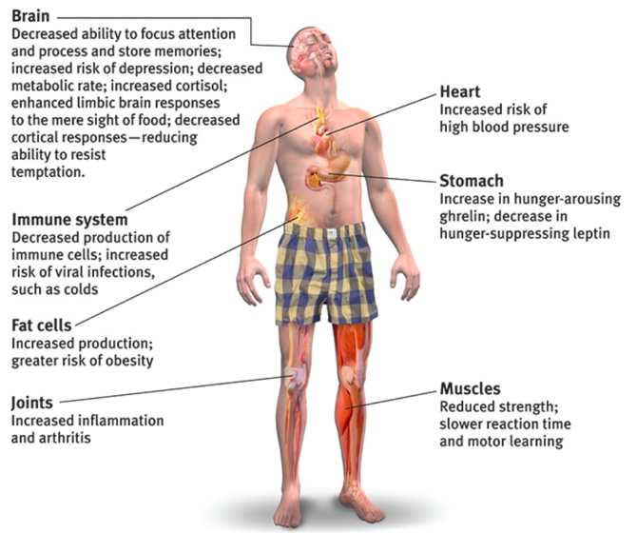

**Natural Sleep Aids**

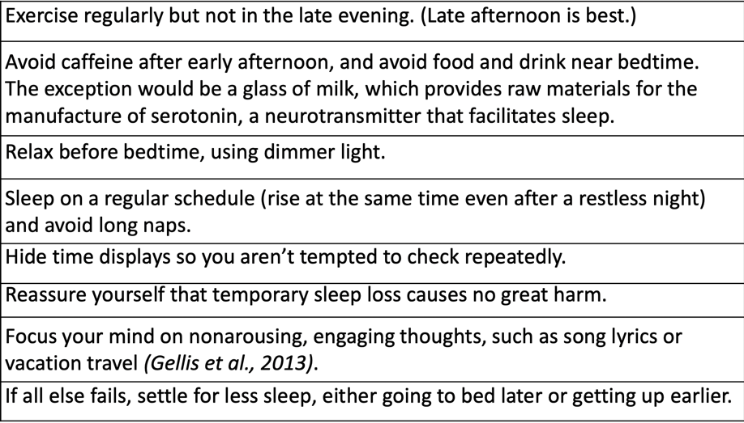

Major Sleep disorders

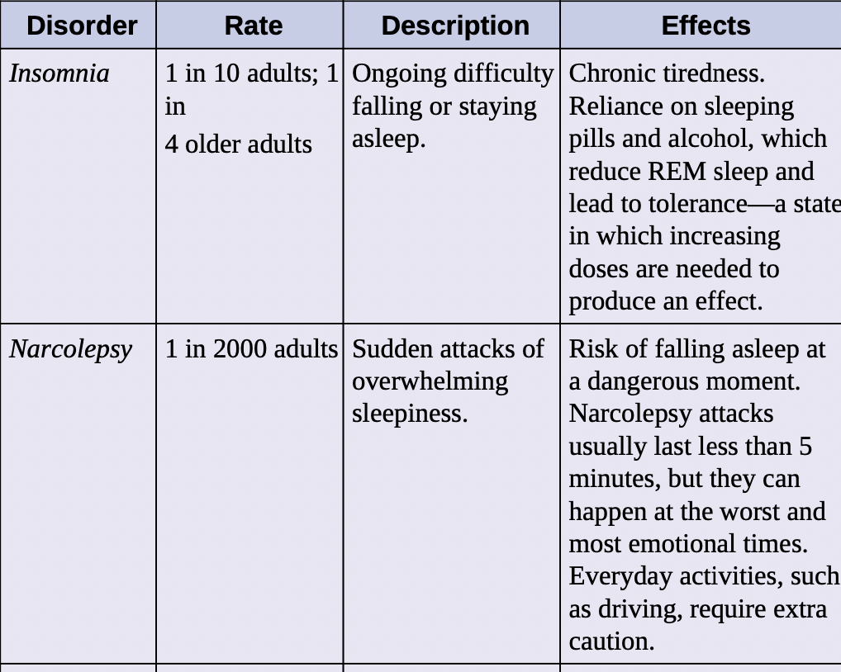

Ironically, insomnia becomes worse when we fret about it. In laboratory studies, people with insomnia do sleep less than others. But they typically **overestimate** how long it takes them to fall asleep and **underestimate** how long they actually have slept

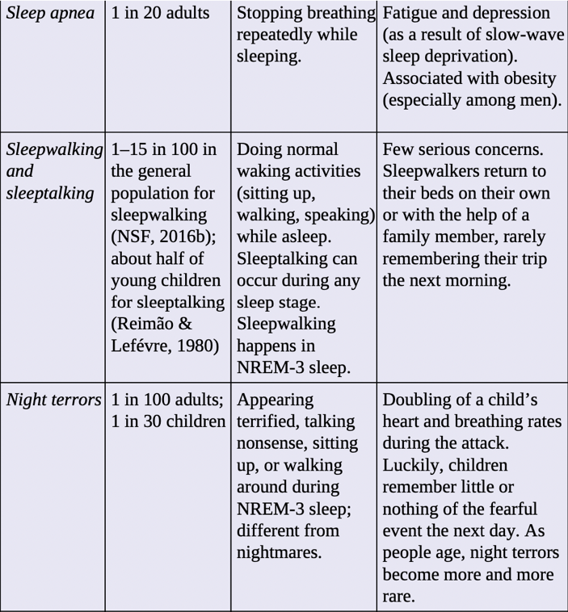

**Dream:**a sequence of images, emotions, and thoughts passing through a sleeping people’s mind

**What do we dream about?**

* 8 in 10 dreams are marked by at least one negative events or emotion
* 1 in 10 dreams among young men and 1 in 30 dreams among young women have sexual content
* A dream’s story line incorporates trace of previous days’ experiences and preoccupations
* Sensory stimuli (odor, phone ringing…) may be instantly woven into the dream story

**Why we dream?**

1. **To satisfy our own wishes**

**Sigmund Freud’s dream wish-fulfillment theory**

He proposed that dreams provide a psychic safety valve that discharges otherwise unacceptable feelings. He viewed a dream’s **manifest content** (the apparent and remembered story line of a dream) as a censored, symbolic version of its **latent content** (the underlying meaning of a dream), the unconscious drives and wishes (often erotic) that would be threatening if expressed directly. Thus, a gun might be a disguised representation of a penis.

**Flawed**: what’s the ground for the dream’s interpretation?

1. **To file away memories**

The ***information-processing* perspective proposes** that dreams may help sift, sort, and fix the day’s experiences in our memory.

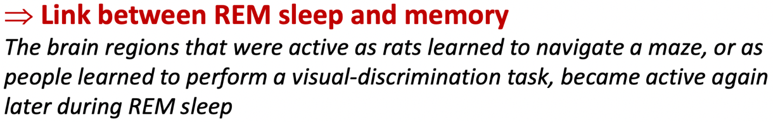

1. **To develop and preserve neural pathways**

***Psychological functions of dreams***: Stimulating experiences **preserve and expand the brain’s neural pathways**. Infants, whose neural networks are fast developing, spend much of their abundant sleep time in REM sleep.

1. **To make sense of neural static**

According to ***activation-synthesis theory****,* dreams are the brain’s attempt to **synthesize random neural activity**.

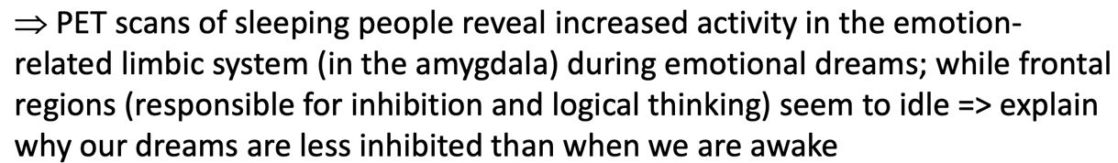

1. **To reflect cognitive development**

Some dream researchers prefer to see dreams as **part of brain maturation and cognitive development.** For example, prior to age 9, children’s dreams seem more like a **slide show** and less like an active story in which the dreamer is an actor. Dreams overlap with waking cognition and feature coherent speech. They *simulate reality* by drawing on our concepts and knowledge. They engage brain networks that also are active during daydreaming—and so may be viewed as intensified mind wandering, enhanced by visual imagery

**Dream Theories:**

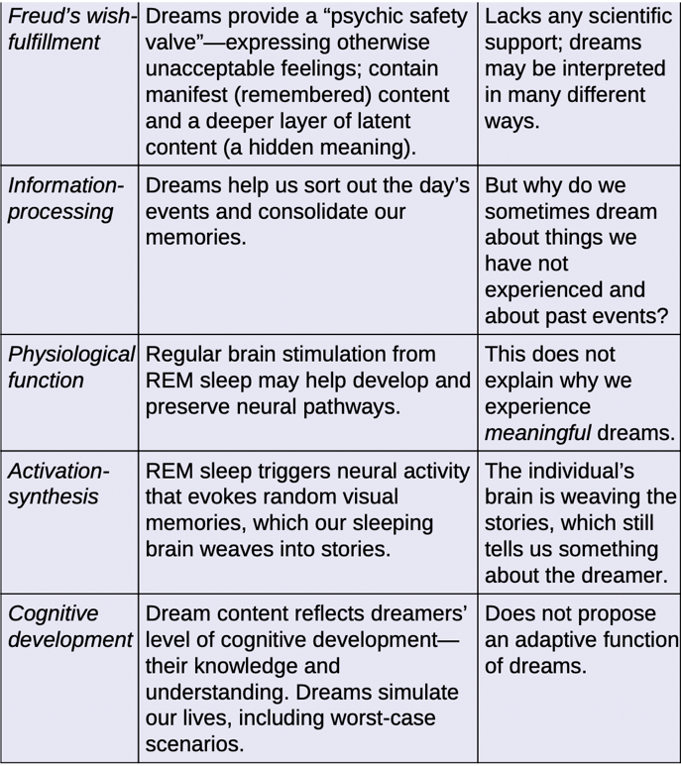

1. **Drugs**

**Drug**: a substance which has a **physiological effect** hen ingested or otherwise introduced into the boy

**Psychoactive drugs**: a chemical substance that **alters perceptions and moods**.

**Eg:** heroin, LSD, cocaine, ecstasy, Fentanyl

Drugs are, by themselves, neither ‘good’ nor ‘bad’.

What makes a drug ‘bad’ depends on its **dosage**, its **frequency** **of use**, and the **context** in which it is used.

Drug and legalization

**How dangerous a drug is have very little to do with whether it is made legal or illegal in a given country**

* The legal restrictions to which each drug is subject vary from one historical period and one country to another

Certain drugs are prohibited in certain cultures (alcohol in Islamic countries)

Alcohol is more lethal than cannabis, but it is legal in every country

* There is a **continuum**, which runs from total prohibition to freely permitted sale.

(the medical consumption of cannabis is legal under specified medical conditions, and the recreational use illegal)

* The traffic in illicit drugs is a **geopolitical factor** that continues to have an extremely heavy impact on our societies.

**Substance use disorder**:

a disorder characterized by continued substance craving and use despite significant life disruption and/or physical risk

* **Tolerance**: the diminishing effect with regular use of the same dose of a drug, requiring the user to take larger and larger doses before experiencing the drug’s effect
* **Withdrawal:** the discomfort and distress that follow discontinuing an addictive drug or behavior.

How to identify if one has disorder?

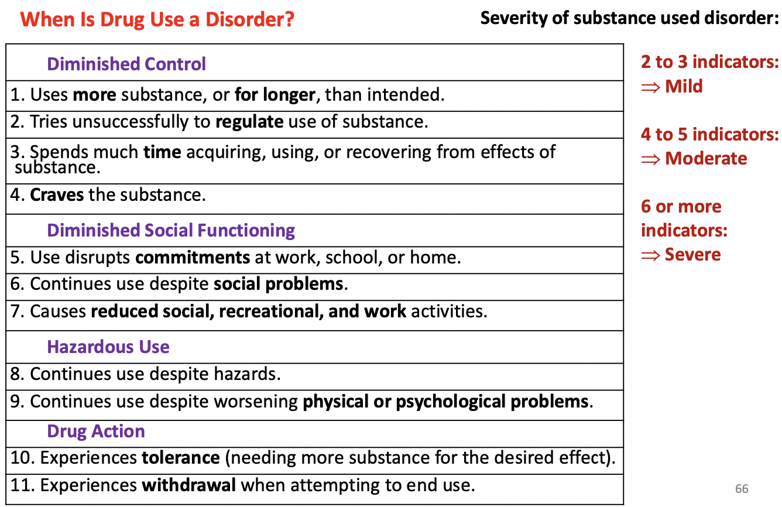

Influence on drug use:

Peer influence

If you have more people drinking around you, you’re more likely to drink alcohol.

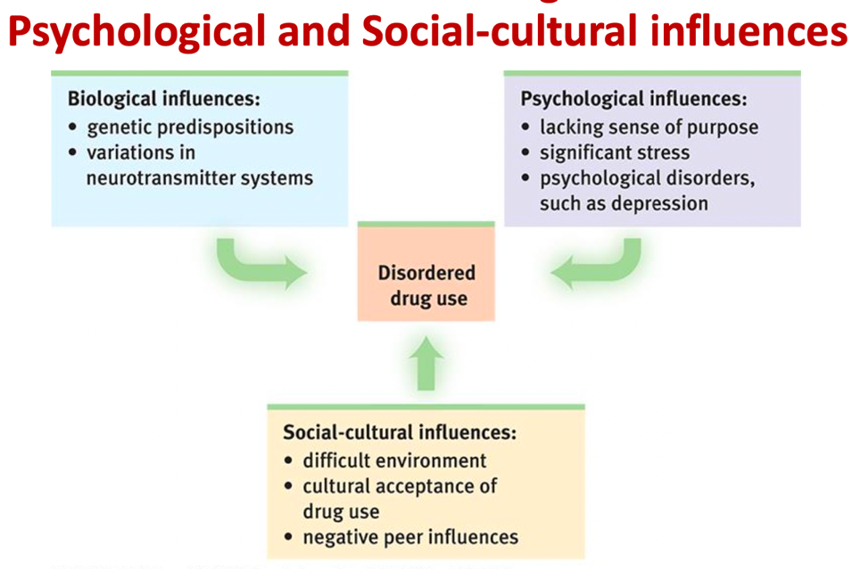

3 major categories of psychoactive drugs:

* Depressants (agonists)
* Stimulants (antagonist: stop the receptor)
* Hallucinogens

**Depressants**: drugs that **reduce neural activity** and **slow body functions** (alcohol, barbiturates, opiates)

**Alcohol(agonist)**

Alcohol acts as a disinhibitor => **slow down neural processing**

* Decrease of motor control
* Decrease of judgement and inhibition, reduced self-awareness and self-control

More sexual aggression, distract from normal inhibition, guilt-free

* Memory disruption
* Expectancy effects: **biological** and **psychological** influences.

**How much alcohol is two much**?

For men: low-risk alcohol consumption (≠0 risk) is considered drinking **4 or fewer** standard drinks on any single day AND less than 14 drinks during a given week.

For women: low-risk alcohol consumption ( (≠0 risk) is considered drinking **3 or fewer** standard drinks on any single day AND less than 7 drinks during a given week

Women, who have less of a stomach enzyme that digests alcohol, are especially vulnerable. Girls and young women can become addicted to alcohol more quickly than boys and young men do, and they are at risk for **lung, brain, and liver** damage at lower consumption levels

**Barbiturates**: tranquilizer. Drug that depresses central nervous system activity, reducing anxiety but impairing memory and judgement

If combined with alcohol, the total depressive effect on body functions can be lethal

**Opiates**: opium and derivatives:

* **Heroin**
* Medically prescribed pain-relief narcotics: **codeine, morphine, methadone**

Depress neural activity, temporarily lessening pain and anxiety

When repeatedly flooded with an artificial opiate, the brain eventually stops producing endorphins (its own opiate)

**Stimulants**: drug that excite neural activity and speed up body functions

**(caffeine, nicotine, cocaine, amphetamines, methamphetamine, ecstasy)**

**Nicotine:** a highly addictive psychoactive drug in tobacco

* Highly addictive: Attempts to quit even within the first weeks of smoking often fail.
* As with other addictions, smoker develop tolerance, and quitting cases withdrawal symptoms, including **craving, insomnia, anxiety, irritability, and distractibility**

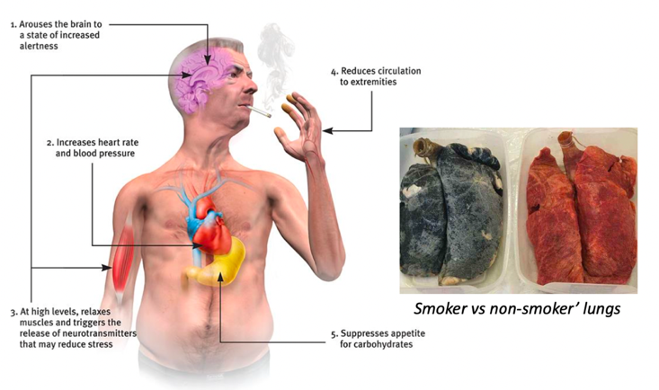

E- cigarettes:

a decade old=> lack of adequate data on long-term effect

* **E-cigarettes do NOT help current smokers quit**
* E-cigarettes deliver toxic chemicals, and can increase one’s chance of using conventional cigarettes

**Cocaine**: a powerful and addictive stimulant derived from the coca plant, produces temporarily increased **alertness and euphoria**

Cocaine’s psychological effect depend in part on the **dosage** and form consumed+ situation+ user’s expectations+ personality

It enters the bloodstream quickly, producing a rush of euphoria that depletes the brain’s supply of the neurotransmitter’s dopamine, serotonin, and norepinephrine

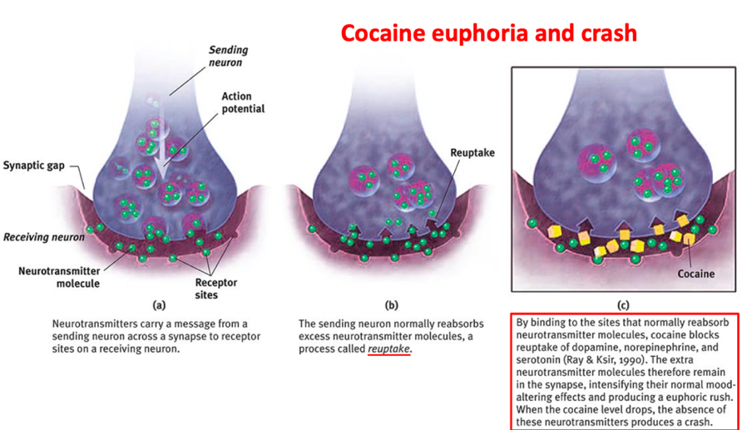

Fluoxetine hydrochloride

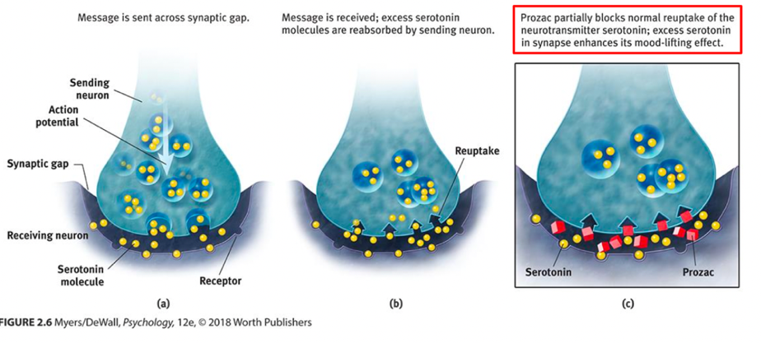

Blocks the uptake of the neurotransmitter serotonin

Why is Prozac so popular?

Nearly all of Prozac’s clearly established effects are indistinguishable from those of classic stimulant

‘anti-empathy’ agent: it disconnects a person from the rest of the world

**Amphetamines**: drugs that stimulate neural activity

**Methamphetamine**: chemically similar, greater effect. Powerfully addictive drug that stimulates the central nervous system. Over time, appears to **reduce baseline dopamine levels**

**Ecstasy** (street name: MDMA, also known in its powder Molly): a synthetic stimulant and mild hallucinogen

* Produces **euphoria** and **social intimacy**
* Short-term health risks and longer-term harm to serotonin-producing neurons and to mood and cognition

**Hallucinogens:**

distort perceptions and evoke sensory images in the absence of sensory input. (Synthetic: LSD, MDMA; natural: marijuana)

Given that oxygen deprivation and other insults to the brain are known to produce hallucinations, it is difficult to resist wondering whether a brain under stress manufactures the near-death experience.

**LSD** (Video): discovered by the chemist Albert Hofmann

The emotions of an LSD (“acid”) trip vary from euphoria to detachment to panic. Users’ mood and expectations color the emotional experience, but the perceptual distortions and hallucinations have some commonalities.

**Psilocybin** (Video)

Video: How psychedelic could help treat anxiety, addiction and depression

**Marijuana:** leaves and flower contain THC

* Amplifies sensitivity to colors, sounds, tastes, smells
* Relaxes, disinhibits, and may produces a euphoric ‘high’
* Impact short-term memory
* Marijuana has positive **proven and potential uses in the medical field**

(video)

* Consuming marijuana before the brain is fully mature (20-25 years) impairs neurodevelopment and has devastating long-term effects
* Heavy use also has a potential long-term effect on brain
* **Moderate consumption** seems to be generally harmless, EXCEPT for individuals with schizophrenic or depressive tendencies

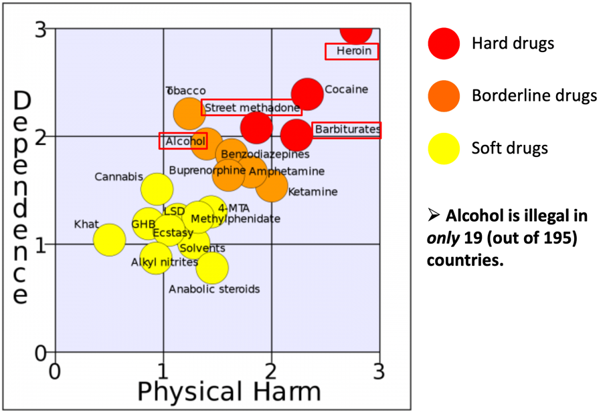

Agonist Drug:

a mimic and it increases the overall activity at the synapse

Antagonist Drug:

a blocker and it decreases the overall activity at the synapse.

How Drugs Affect the Nervous System

While drugs can be classified as either an agonist or antagonist, they ways they have their effects are varied.

Drugs that are agonists can act like the neurotransmitter, called mimics, keep the drug in the synapse longer, or cause more of the neurotransmitter to be produced, for example.

Drugs that are antagonists can prevent the neurotransmitter from binding, called blockers, destroy the neurotransmitter, or interfere with the production of the neurotransmitter, for example.

